* **Activity 1**:

Creating Natural Joins

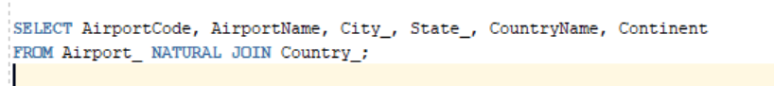

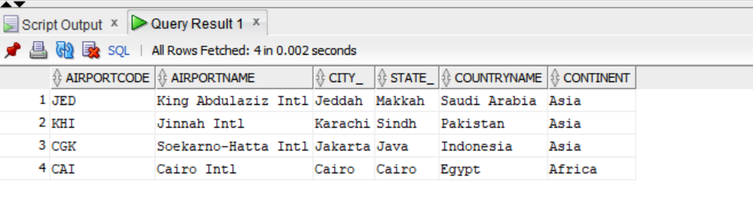OUTPUT:

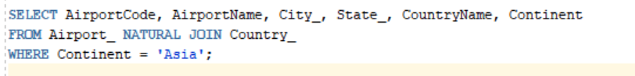**Adding a WHERE Clause**

OUTPUT:

